تصريح عمل

Submitter Detail
تفاصيل المرسل
User ID: |  |  | Name: |  |  |  | Contact Number:
الرقم الوظيفي |  |  | الاسم |  |  |  | رقم التواصل
Command: |  |  | Unit: |  | Tarasul No:
القيادة |  |  | الوحدة |  | رقم التراسل

Basic Details
تفاصيل اساسية
Command: |  |  |  |  | Unit: |  |  | Sub Unit:
القيادة |  |  |  |  | الوحدة |  |  | القسم
Assessment Date: |  |  |  |  |  | Assessment Time: |  |  |  |  | Assessor Command:
تاريخ التقييم |  |  |  |  |  | وقت التقييم |  |  |  |  | القيادة المقيم
Topic:
الموضوع
Assessment Team: Name: |  |  |  |  |  |  |  | ID#: |  |  |  | Role: |  |  |  | Contact #:
فريق التقييم |  |  |  | الاسم |  |  |  | الرقم |  |  |  | الدور |  |  |  | رقم التواصل
Assessment Team: Name: |  |  |  |  |  |  |  | ID#: |  |  |  | Role: |  |  |  | Contact #:
فريق التقييم |  |  |  | الاسم |  |  |  | الرقم |  |  |  | الدور |  |  |  | رقم التواصل

General Details
تفاصيل عامة
Job Description:
وصف العمل
Emirate: |  |  |  | Base/Area: |  | Location: |  | Building:
الامارة |  |  |  | المنطقة |  | الموقع |  | المبنى
Remarks:
الملاحظات

Risk Assessment #:
تقييم المخاطر رقم:
Subtask:
المهمة الفرعية
Initial Hazard/Risk:  الخطر الأولي |  |  | Category: |  |  |  |  |  | Specific:
 |  |  | الفئة |  |  |  |  |  | محددة بـ
 |  |  | Probability: |  |  |  |  |  |  | Severity: |  |  |  |  |  |  |  |  | Initial Risk:
 |  |  | الاحتمالية |  |  |  |  |  |  | الشدة |  |  |  |  |  |  |  |  | المخاطرة الاولية
Existing Controls: |  |  | ☐Elimination |  |  |  | ☐Substitution |  |  |  |  | ☐Engineering |  |  |  |  | ☐Administrative |  |  |  |  | ☐PPE |  |  | Evaluation:
التدابير المتوفرة حالياً |  |  | إزالة |  |  |  | الاستبدال |  |  |  |  | التحكم الهندسي |  |  |  |  | التحكم الاداري |  |  |  |  | المعدات الشخصية |  |  | التقييم
Control & Residual Risk  التحكم والمخاطر المتبقية |  |  |  | New Control: |  |  |  |  |  |  |  |  | Control Subtype: |  |  |  |  |  |  |  |  |  | Remarks:
 |  |  |  | تدابير جديدة |  |  |  |  |  |  |  |  | النوع الفرعي للتدابير |  |  |  |  |  |  |  |  |  | الملاحظات
 |  |  |  | Residual Risk: |  |  |  |  |  |  | Evaluation:
 |  |  |  | المخاطر المتبقية |  |  |  |  |  |  | التقييم
Control Measures/Actions:
الإجراءات التصحيحية
Action Officer: |  |  |  |  |  |  |  |  |  |  |  |  | Due Date:
الضابط المخول للعمل |  |  |  |  |  |  |  |  |  |  |  |  | تاريخ الانتهاء

Risk Assessment #:
Subtask:
المهمة الفرعية
Initial Hazard/Risk:  الخطر الأولي |  |  | Category: |  |  |  |  |  | Specific:
 |  |  | الفئة |  |  |  |  |  | محددة بـ
 |  |  | Probability: |  |  |  |  |  |  | Severity: |  |  |  |  |  |  |  |  | Initial Risk:
 |  |  | الاحتمالية |  |  |  |  |  |  | الشدة |  |  |  |  |  |  |  |  | المخاطرة الاولية
Existing Controls: |  |  | ☐Elimination |  |  |  | ☐Substitution |  |  |  |  | ☐Engineering |  |  |  |  | ☐Administrative |  |  |  |  | ☐PPE |  |  | Evaluation:
التدابير المتوفرة حالياً |  |  | إزالة |  |  |  | الاستبدال |  |  |  |  | التحكم الهندسي |  |  |  |  | التحكم الاداري |  |  |  |  | المعدات الشخصية |  |  | التقييم
Control & Residual Risk  التحكم والمخاطر المتبقية |  |  |  | New Control: |  |  |  |  |  |  |  |  | Control Subtype: |  |  |  |  |  |  |  |  |  | Remarks:
 |  |  |  | تدابير جديدة |  |  |  |  |  |  |  |  | النوع الفرعي للتدابير |  |  |  |  |  |  |  |  |  | الملاحظات
 |  |  |  | Residual Risk: |  |  |  |  |  |  | Evaluation:
 |  |  |  | المخاطر المتبقية |  |  |  |  |  |  | التقييم
Control Measures/Actions:
الإجراءات التصحيحية
Action Officer: |  |  |  |  |  |  |  |  |  |  |  |  | Due Date:
الضابط المخول للعمل |  |  |  |  |  |  |  |  |  |  |  |  | تاريخ الانتهاء

Risk Assessment #:
Subtask:
المهمة الفرعية
Initial Hazard/Risk:  الخطر الأولي |  |  | Category: |  |  |  |  |  | Specific:
 |  |  | الفئة |  |  |  |  |  | محددة بـ
 |  |  | Probability: |  |  |  |  |  |  | Severity: |  |  |  |  |  |  |  |  | Initial Risk:
 |  |  | الاحتمالية |  |  |  |  |  |  | الشدة |  |  |  |  |  |  |  |  | المخاطرة الاولية
Existing Controls: |  |  | ☐Elimination |  |  |  | ☐Substitution |  |  |  |  | ☐Engineering |  |  |  |  | ☐Administrative |  |  |  |  | ☐PPE |  |  | Evaluation:
التدابير المتوفرة حالياً |  |  | إزالة |  |  |  | الاستبدال |  |  |  |  | التحكم الهندسي |  |  |  |  | التحكم الاداري |  |  |  |  | المعدات الشخصية |  |  | التقييم
Control & Residual Risk  التحكم والمخاطر المتبقية |  |  |  | New Control: |  |  |  |  |  |  |  |  | Control Subtype: |  |  |  |  |  |  |  |  |  | Remarks:
 |  |  |  | تدابير جديدة |  |  |  |  |  |  |  |  | النوع الفرعي للتدابير |  |  |  |  |  |  |  |  |  | الملاحظات
 |  |  |  | Residual Risk: |  |  |  |  |  |  | Evaluation:
 |  |  |  | المخاطر المتبقية |  |  |  |  |  |  | التقييم
Control Measures/Actions:
الإجراءات التصحيحية
Action Officer: |  |  |  |  |  |  |  |  |  |  |  |  | Due Date:
الضابط المخول للعمل |  |  |  |  |  |  |  |  |  |  |  |  | تاريخ الانتهاء

Risk Assessment #:
Subtask:
المهمة الفرعية
Initial Hazard/Risk:  الخطر الأولي |  |  | Category: |  |  |  |  |  |  |  | Specific:
 |  |  | الفئة |  |  |  |  |  |  |  | محددة بـ
 |  |  | Probability: |  |  |  |  |  |  |  |  | Severity: |  |  |  |  |  |  |  |  |  | Initial Risk:
 |  |  | الاحتمالية |  |  |  |  |  |  |  |  | الشدة |  |  |  |  |  |  |  |  |  | المخاطرة الاولية
Existing Controls: |  |  | ☐Elimination |  |  |  |  | ☐Substitution |  |  |  |  |  | ☐Engineering |  |  |  |  |  | ☐Administrative |  |  |  |  |  | ☐PPE |  |  | Evaluation:
التدابير المتوفرة حالياً |  |  | إزالة |  |  |  |  | الاستبدال |  |  |  |  |  | التحكم الهندسي |  |  |  |  |  | التحكم الاداري |  |  |  |  |  | المعدات الشخصية |  |  | التقييم
Control & Residual Risk  التحكم والمخاطر المتبقية |  |  |  |  | New Control: |  |  |  |  |  |  |  |  |  | Control Subtype: |  |  |  |  |  |  |  |  |  |  |  | Remarks:
 |  |  |  |  | تدابير جديدة |  |  |  |  |  |  |  |  |  | النوع الفرعي للتدابير |  |  |  |  |  |  |  |  |  |  |  | الملاحظات
 |  |  |  |  | Residual Risk: |  |  |  |  |  |  |  | Evaluation:
 |  |  |  |  | المخاطر المتبقية |  |  |  |  |  |  |  | التقييم
Control Measures/Actions:
الإجراءات التصحيحية
Action Officer: |  |  |  |  |  |  |  |  |  |  |  |  |  |  | Due Date:
الضابط المخول للعمل |  |  |  |  |  |  |  |  |  |  |  |  |  |  | تاريخ الانتهاء
Overall Risk
المخاطر الشاملة
Overall Initial Risk:  المخاطر الأولية الشاملة |  |  |  |  |  |  |  |  | Overall Residual Risk:  المخاطر المتبقية الشاملة

Communication and Emergencies
التواصل والطوارئ
Communication Plan:
خطة التواصل
Users and Co-located workers made aware? ☐ |  |  | Safety Notes, Cautions, & Warnings required? ☐
تم اعلام المستخدمين والعاملين بالموقع |  |  | ملاحظات السلامة والتحذيرات
Emergency Plan:
خطة الطوارئ

Supervision
الاشراف
Name: |  |  |  |  |  | ID#: |  |  |  | Rank:
الاسم |  |  |  |  |  | الرقم |  |  | الرتبة
Signature: |  |  |  | Date:
التوقيع |  |  |  | التاريخ
Supervision Plan/Remarks:
خطة الاشراف والملاحظات

Approval
الاعتماد
Name: |  |  |  |  |  | ID#: |  | Rank:
الاسم |  |  |  |  |  | الرقم |  | الرتبة
Determination: |  | ☐Approve |  | ☐Disapprove | Signature: |  |  |  |  | Date:
الموافقة |  | القبول |  | عدم القبول | التوقيع |  |  |  |  | التاريخ
Additional Guidance:
إرشادات إضافية

Supporting Documents
Attachments: | 1. | 2. | 3.
المرفقات

***END OF FORM***

Purpose: To ensure the proper authorization of non-routine hazardous work, or work where there is a higher level of risk than regular operations. These operations may involve unfamiliar procedures, unfamiliar equipment, or working in unfamiliar areas. The PTW system clarifies to workers the exact identity, nature, and extent of the job and the hazards involved. It also specifies the precautions to be taken, communication required, and emergency actions required while responding to a mishap.

Work not requiring a permit
- Routine tasks in established workshops and adjacent boundaries
- Routine material handling tasks in warehouses and lay down areas
- Routine office work
- Visual inspection or checking without using any tools in operation areas with verbal permission from equipment operator/custodian.
- Tasks carried out by operation employees as part of their daily tasks.
- Tasks carried out in designated areas declared as work permit-free by the appropriate authority.

Instructions:
Complete JAC FORM 385-9 Permit to Work by following the instructions below. A Permit to Work shall be established for the following types of non-routine work, as a minimum, when there is no specific established work process in place:
- Permit Required Confined Space (PRCS)
- Lock Out/Tag Out (Energy Isolation)
- Hot Work (Spark Producing: Welding, Cutting, Grinding, etc.)
- Scaffolding
- Excavation (Deeper than 1.5m)
- Radiation Hazards
- Other circumstances including work on specifically identified equipment
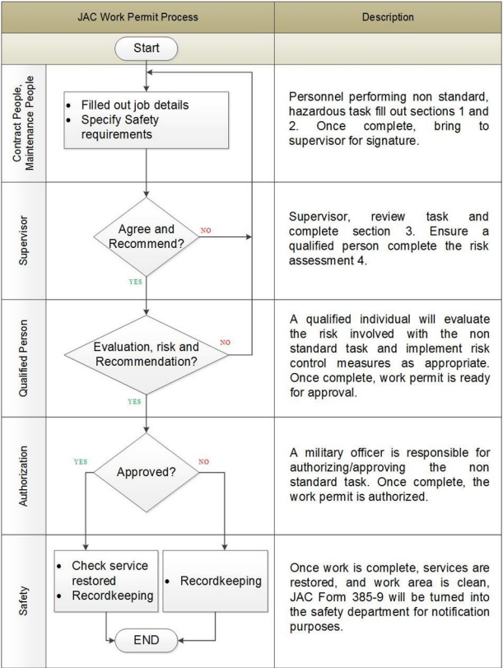

FIELD | INSTRUCTION

Submitter Details
User ID: | Enter military or civilian employee Identification number of the person submitting the form
Name: | Enter name of person submitting the form
Submit Date: | Enter the date the form was initiated. (DD/MM/YYYY)
Submit Time: | Enter the time form was initiated.
Contact #: | Enter contact phone number of the person submitting the form

Basic Details
Command: | Enter the Command conducting the job task (Group 18, NAG, Group 10, JAI, ASC, SAS, SAB, ect.)
Unit: | Enter the organizational unit conducting the job task. (Battalion)
Sub Unit: | Enter the organizational sub-unit conducting the job task. (sheet metal shop, engine shop, etc.)
Assessment Date: | Enter date of risk assessment (DD/MM/YYYY)
Assessment Time: | Enter the time risk assessment
Assessor Command: | Enter the command of the team conducting the assessment.
Topic: | Enter the permit to work topic. Include task and hazardous activity that requires the permit to work. For example, [Fuel cell cleaning: Permit Required Confined Space Entry] or [Machine repair: LOTO]
Assessment Team: Name | Enter name of the team member
ID: | Enter military number or employee number of the team member
Role: | Enter the role of the assessment team member. If only one person, enter Lead. Choose from the following options:  - Lead (person in charge of assessment)  - Participant (personnel assisting survey, but not in charge)
Contact #: | Enter contact phone number of assessment team member

General Details
Job Description: | Enter a description of the job to be performed. This is a brief description that ensures anyone reading the form will understand the objective of the work to be done. For example [Clean fuel cell in accordance with Technical Manual XXX]
Emirate: | Enter the Emirate where the job task will be conducted
Base/Area: | Enter the Base/Area where the job task will be conducted
Location: | Enter the location where the job task will be conducted
Building: | Enter the building # where the job task will be conducted. For example, hangar 34, Blue Apron, runway 34, etc.
Remarks: | Enter the specific location where the job task will be conducted. For example, room 24, sheet metal shop, parking pad 2, etc.  Enter any other details that are relevant to a general description of the work to be done.

Risk Assessment
Subtask: | Enter the individual task that requires a permit to work. For example, [Confined space entry into fuel cell]
[SUBSECTION] Initial Hazard/Risk:
Category: | Enter the hazard category from the following list of options:  - Radiation  - Environmental (Pollution)  - Work Environment  - Fire & Explosion  - Electrical  - Material Handling  - Biological  - Vehicle Movement  - Chemical  - Mechanical
Specific: | Enter the specific hazard associated with the hazard & risk category from the previous field. Choose from the following options:
  Radiation | Environmental (Pollution
  - Non-Ionizing Radiation  - Ionizing Radiation | - Release to Air  - Release to Water  - Release to Land
  Work Environment | Mechanical
  - Lighting  - Vibration  - Heat  - Humidity  - Noise  - Weather  - Dust  - Pollution  - Condition of Building or Place  - *Work at Height  - *Wildlife  - *Other | - Vibrating  - Stuck  - Hole (puncture)  - Scratch  - Pulling  - Pressure  - Stabbing  - Cut  - Blast / Explosion  - Noise
  Electrical | Material Handling
  - Permanently Installed Fixtures  - Portable Equipment & Tools | - Mechanical Handling  - Handling Material
  Biological | Vehicle Movement
  - Bacteria  - Fungi  - Viruses | - Rollover  - Run Over
  Chemical | Fire & Explosion
  - Fumes  - Poisons  - Gas  - Incendiaries  - Carcinogens  - Irritants | - Ammunition & Munitions  - Flammable Materials, Gases, & Liquids
Probability: | Use the risk matrix to determine the probability of occurrence. Enter one of the following options:  - 1 Unlikely  - 2 Seldom  - 3 Occasional  - 4 Likely  - 5 Frequent
Severity: | Use the risk matrix to determine the severity of exposure to the hazard. Enter one of the following options:  - 1 Negligible  - 2 Minor  - 3 Major  - 4 Hazardous  - 5 Catastrophic
Initial Risk: | Use the risk matrix to determine the risk by multiplying the probability and severity. Enter one of the following risk value options based on the numerical result:  - Extremely High  - High  - Medium  - Low  - Very Low
Existing Controls: | Check the boxes of all existing controls currently in place that help mitigate the hazard. Check all that apply. If there are no existing controls, select None.
Evaluation: | Determine if the current controls are adequate. Enter one of the following options:  - Acceptable  - Unacceptable  - Uncertain
[SUBSECTION] Control & Residual Risk:
New Control: | Enter the recommended new control measure. Refer to JAC REG 385-5 "Risk Management".  Hierarchy of Controls  - Risk Removal – (Elimination): Remove the hazard from the work place.  - Risk Mitigation – (Substitution): Replacing the hazardous with less hazardous materials, processes, operations or equipment.  - Engineering Control: Using isolation, machine guarding, ventilation, etc.  - Administrative Control: Giving appropriate instructions to personnel (lockout process, driving licenses, safety signs, etc.).  - PPE: Provide PPE and instructions for utilization and maintenance.  Safety Order of Precedence  The hierarchy of controls shall be implemented in the order of precedence. The most effective safety control should be implemented first. If it is not possible, the next most effective control should be considered. Multiple controls may need to be implemented in order to reduce a hazard to the lowest risk possible.
Control Subtype: | Enter the control subtype based on the type of new control entered. See table below.
  Risk Removal | Administrative Control
  - Remove dangerous materials or tools  - Remove complete activity | - Update regulation  - Update procedures  - Update Instructions  - Update guidelines  - Update Training  - Update Education
  Engineering Control | Risk Mitigation
  - Insulation (new design)  - Insulation (design modification)  - New Engineering design/construction  - Regular maintenance work | - Substitution of materials  - Automatic fire system  - Fire extinguishers
  Other Controls | PPE
  - Other controls | - Provide protective equipment  - Replacement of protective equipment
Remarks: | Describe specific controls to be used. For example [I-beam clamp, lanyard, and fall protection harness to be worn by all personnel performing unprotected work above 1.2 meters]
Residual Risk: | Enter remaining risk after control measures if control measures are implemented. Enter one of the following options:  - Extremely High  - High  - Medium  - Low  - Very Low
Evaluation: | Determine if the new control is adequate. Enter one of the following options:  - Acceptable  - Unacceptable  - Uncertain
[SUBSECTION] Control Measures/Actions:
Action Officer: | Enter the section or person responsible to implement the corrective measure/action.
Due Date: | Enter the suspense date (due date) of the corrective measure/action. (DD/MM/YYYY)  EH / H = 15 days maximum  M / L = 30 days maximum  See JAC REG 385-5 Risk Management
Overall Risk
Overall Initial Risk: | Enter highest initial risk from subtasks.
Overall Residual Risk: | Enter highest residual risk from subtasks.
Communication and Emergencies
Communication Plan: | Describe how workers will communicate with each other and with co-located workers in the area. Types of communication include, but is not limited to: signs, barricades, audible and visual (lights) warnings, Official communication/coordination through memos, pre-briefings, etc.
Users and Co-located workers made aware? | Check the box when co-located workers have been made aware, i.e. communication plan has been executed.
Safety Notes, Cautions, & Warnings required? | Describe any safety notes, cautions, and warnings required in and around the work area.
Emergency Plan: | Describe the plan to be followed in case of emergency. This entry must be detailed enough for all to understand what to do and who will do it. Plans may include alerting the fire department of the planned activity. Ensure all equipment necessary to execute the emergency is identified and available.
Supervision
Name: | Enter supervisor’s name
ID#: | Enter supervisor’s ID#
Rank: | Enter supervisor’s rank or enter Civilian
Signature | Supervisor: Sign in this field
Date | Enter the date of signature (DD/MM/YYYY)
Supervision Plan/Remarks: | Describe the supervision plan associated with the permit to work task. Who will be supervising, will there be an assigned “safety watch” or observer?
Approval
Name: | Enter approval officer’s name
ID#: | Enter approval officer’s military ID number
Rank: | Enter approval officer’s rank
Determination: | Approval Officer: check the Approve or Disapprove box
Signature: | Approval Officer: sign in this field
Date: | Enter the date of signature (DD/MM/YYYY)
Additional Guidance: | Enter any additional guidance from approval officer.
* JAC RISK APPROVAL AUTHORITY* (JAC REG 385-5)
Extremely High – JAC Commander | High – Group Commander | Medium – Battalion Commander | Low/Very Low – Company/Squadron CMD

Supporting Documents
Attachments | List any supporting documents
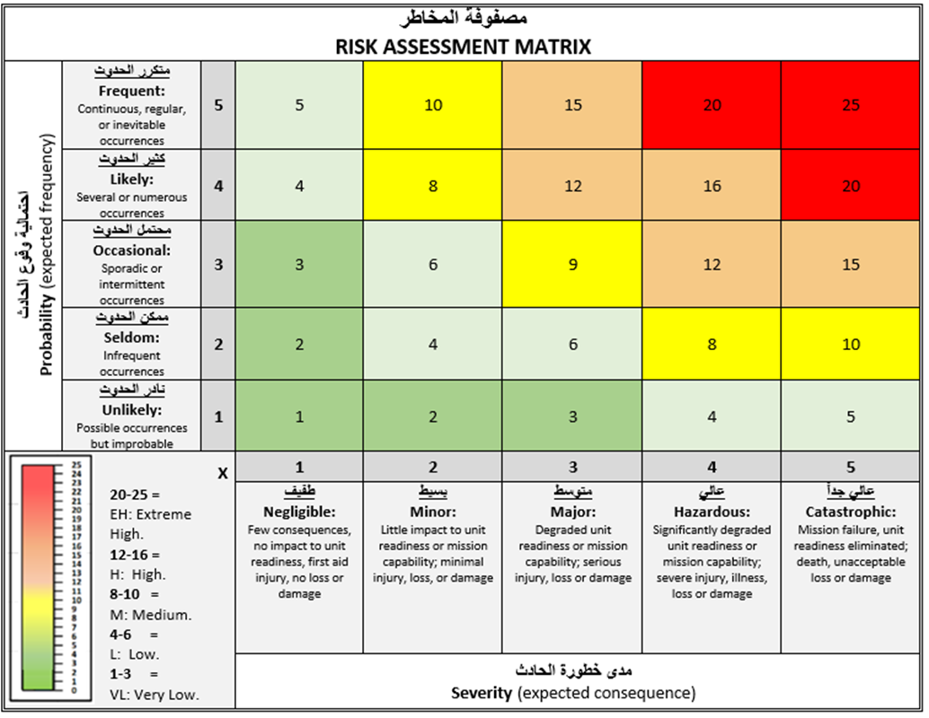

Once form is complete:
- Post a copy at the work site during permit to work activities.
- Submit a copy of the completed form to the unit safety section.

Safety Officer: Enter into Esnaad Safety Management System (SMS) permanent records.
Refer to the JAC ESMS Handbook for further guidance.

